November 13, 2012

First Grade News

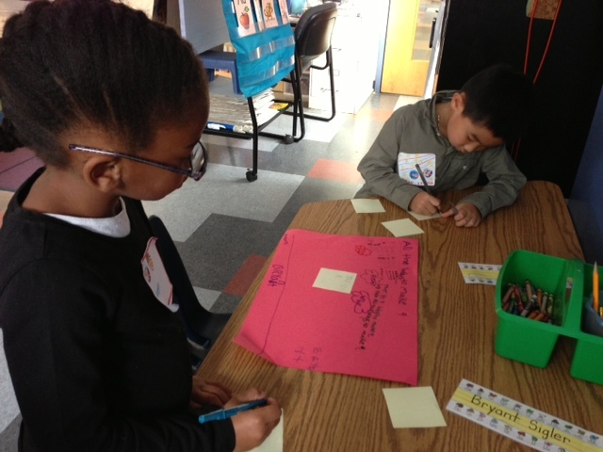

Mr. Franks and Ms. Keeper

keeperfranks.weebly.com

### News

* Congratulations to Amari Taylor our newest Student Spotlight!
* Wednesday is an early dismissal day.
* Attached to the newsletter is this week’s homework- the reading log. The goal is at least 2 hours of reading every week. Please return the completed book log next Monday. There are also 5 sight words attached to the newsletter. Please review these words with your child until s/he knows them automatically.
* Please remember to complete our monthly math homework calendar. We’ll collect them on Dec. 3. If you have questions about how to use this or suggestions for future calendars, please let us know!
* **Progress report meetings are this week! Your meeting time is highlighted on your sign-up sheet. Please bring your child to your meeting. If you have not requested a meeting time please sign-up for a time as soon as possible.**

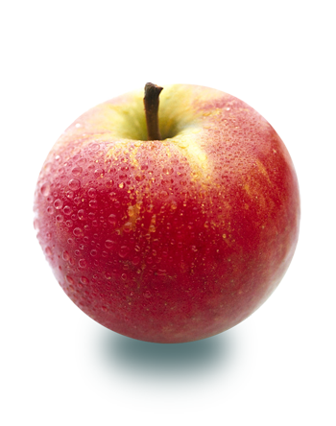

#### Save the Date!

##### Progress Report Meetings

We look forward to meeting with all families!

Wed., Nov. 21

Early dismissal. No lunch served.

##### 11:30 Dismissal

Last week we wrapped up our math unit Apple Boxes and Bunk Beds. The goal of this unit was for students to be able to find all the combinations of a number. For example, the combinations of five are: 5+0, 4+1, 3+2, 2+3, 1+4, 0+5. Students used two strategies to find all the combinations. The strategies are: 1. using turn-around facts and/or 2. using number order. Students created a poster with a partner to show all the combinations of a number. Come see these posters hanging in our classroom!

Last week we also finished up our American symbols unit. Students put the finishing touches on their very own American symbols books. They wrote facts about our final American symbol, the President, and added a table of contents. Look for these books to be coming home soon!

No School!

# What’s Happening in First Grade?

Nov. 13-16th

##### 11:30 Dismissal Day

Nov. 22-23

11:30 dismissal. No lunch served.

##### Thanksgiving break