November 19, 2012

First Grade News

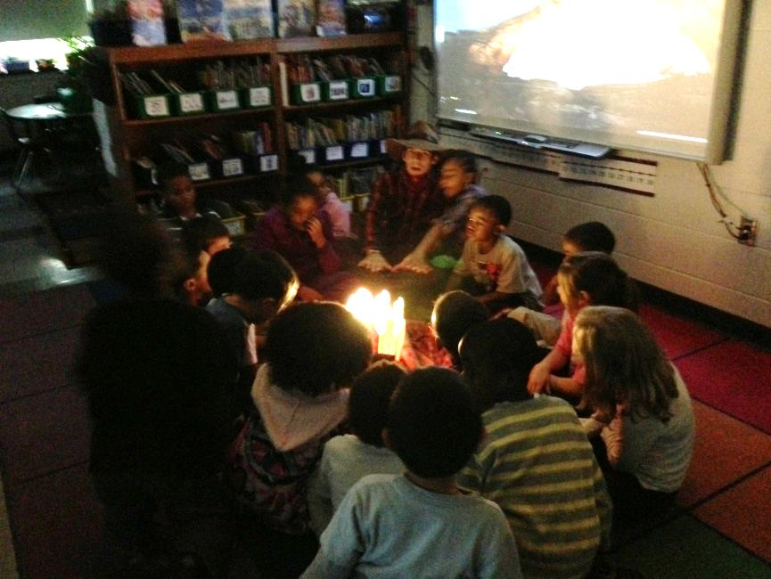

**Mr. Franks and Ms. Keeper**

**keeperfranks.weebly.com**

### News

* Wednesday is an 11:30 dismissal day. Lunch will not be served. There will be no afternoon buses and no afterschool.
* No school Thursday or Friday-Happy Thanksgiving!
* Attached to the newsletter is this week’s homework- the reading log. There are also 10 sight words attached to the newsletter. Please review these words with your child until s/he knows them automatically.
* Thank you to all families for attending progress report meetings. We have LOVED meeting with everyone. Many thanks for all of your support at home.
* Scholastic book orders are coming home today! Book orders and money (cash or check) are due by Thursday, Nov. 29th. You can place your order online at [www.clubs.scholastic.com/](http://www.clubs.scholastic.com/) using our class activation code **GZJR4** and receive a $5 coupon to use towards your next order!
* Please turn this newsletter over for news about our current math unit and ideas for working on math at home.

#### Save the Date!

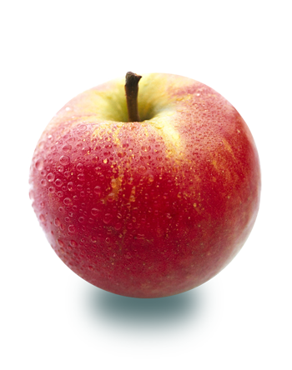

# What’s Happening in First Grade?

Last week we began our new integrated social studies unit Gather ‘Round the Campfire a unit about American Tall Tales and folktales around the world. On Tuesday we began the unit with a “hook” to grab everyone’s attention and get them excited about our new unit. We set up a pretend campfire on our front carpet, pulled down the shades and gathered ‘round the fire with a cowboy and cowgirl. We discussed the question “What is storytelling?” and looked at pictures of some tall tales characters we would meet and read stories about. Later on in the morning we set-up stations around the room to learn about what life was like long ago to help set the stage for the tall tales we would hear. Then on Wednesday, we gathered ‘round the fire again to hear about our first tall tale-Johnny Appleseed. Ask your child to tell you about him!

Dec. 3-7

Wed. Nov. 21

Nov. 22-23

Early dismissal. No lunch served. No afternoon buses or after school program.

##### 11:30 Dismissal

More information coming soon!

##### Scholastic Book Fair at NHCS

##### Thanksgiving break

No School!

More information coming soon!

# Math

Please remember to complete our monthly math homework calendar. We’ll collect the math calendars on **Monday, Dec. 3rd .** If you have questions about how to use this or suggestions for future calendars, please let us know!

We recently began on our third math unit, Solving Story Problems. In this unit students will…

* Continue working on finding combinations of numbers (ie 5+0, 4+1, 3+2, 2+3, 1+4, 0+5)
* Practice “counting on” (so if a student was solving 7+3 s/he would say “7 and count on 3 more 8, 9, 10 instead of starting at 1)
* Deepen their understanding of addition and subtraction through games
* Solve addition and subtraction story problems
* Count larger amounts (up to 120)

Attached to this newsletter are the directions and game boards for a few of our favorite games to practice addition or subtraction-5 in a Row and Roll & Record. These are great games to practice at home. You can find and print these games and more on our class website keeperfranks.weebly.com

