November 5, 2012

First Grade News

Mr. Franks and Ms. Keeper

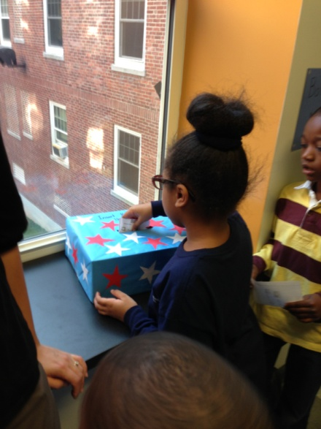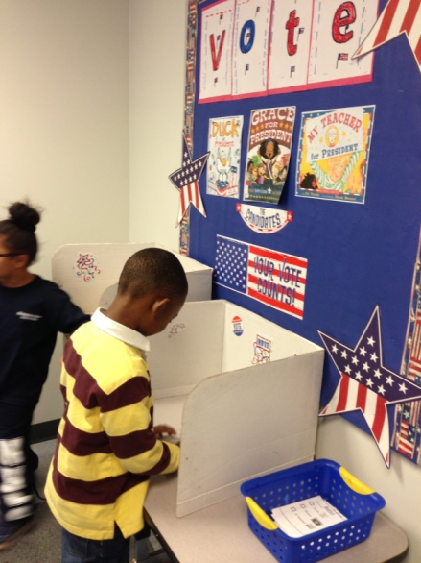

### News

* Thank you to all families that sent in goodies for our party last Friday!
* Attached to the newsletter is this week’s homework- the reading log. The goal is at least 2 hours of reading every week. Please return the completed book log next Monday. There are also 5 sight words attached to the newsletter. Please review these words with your child until s/he knows them automatically.
* Our new math homework calendar is coming home today! If you have questions about how to use this or suggestions for future calendars, please let us know!
* Please review the attached sheet for “Ways to Make 5” with your child.
* **Progress report/goal setting meeting time is here! Look for the sign up sheet tomorrow to choose your meeting time!**
* Check out our updated class website and blog! See photos of what’s happening, print math games, and much more! **keeperfranks.weebly.com**

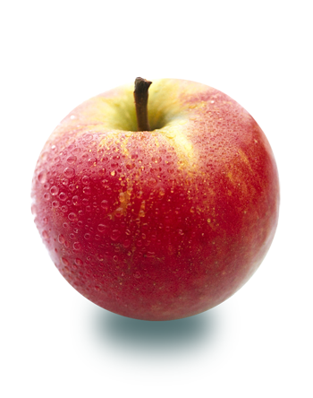

#### Save the Date!

##### Veteran’s Day

# What’s Happening in First Grade?

No School!

Monday, Nov. 12

Look for the sign up sheet coming home tomorrow! We look forward to meeting with all families!

Nov. 13-16th

##### Early Dismissal Day

Last week first grade focused on the upcoming election. First and second grade together held our own mock election. We read three books about characters wanting to be president-Duck for President, Grace for President and My Teacher for President. After reading each book we listed the traits that described each "candidate." For example first grade said that Grace was "calm, peaceful, polite, determined, brave, courageous, and hard-working." At the end of the week, students wrote independently about which character s/he was going to vote for and why. Then we headed to the polls and voted for a character for president. Our class vote was split between the characters. Finally, on Friday first and second grade got together to look at the votes cast from each class. The winner was Grace! This week we will continue to talk about our presidential election. **Don't forget to vote tomorrow (Tuesday, Nov. 6th)!**

Wed., Nov. 14

12:15 dismissal

##### Early Dismissal Day

##### Progress Report Meetings

No School!