First Grade News

October 15, 2012

#### Save the Date!

### News

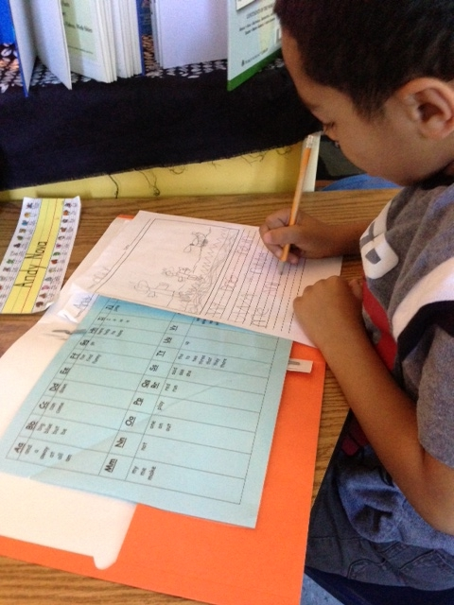

Mr. Franks and Ms. Keeper

* Congratulations to Jacob Cataloni our newest Student Spotlight
* Attached is this week’s homework- the reading log. Our goal is 2 hours of reading a week. Please return the completed log next Monday.
* This Thursday evening is the Parent Workshop on How to Help your Child Become a Better Reader. Pizza at 5:30 pm and the program starts at 6pm.
* Don’t forget to save and send in your “Boxtops for Education.” Money raised supports our incredible music program.
* Scholastic Book orders are coming home today! Forms and money (cash or check) are due Wednesday, Oct. 24th. Order online at [www.clubs.scholastic.com/](http://www.clubs.scholastic.com/) Our class activation code is **GZJR4**
* Check out our new blog on our class website at keeperfranks.weebly.com

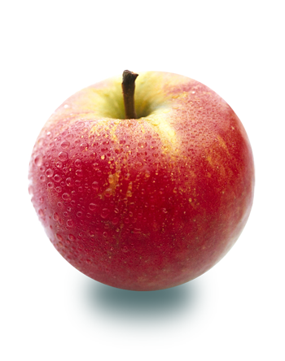

Last week we received our first issue of National Geographic Young Explorer! We read the first two articles together as a class on the SMARTboard. The first article was about Life in the Rain Forest. Students learned that rain forest animals need food, water, and air to survive. The second article was called Stormy Sky. We learned about hurricanes. Each student will receive his/her own copy of National Geographic Young Explorer monthly to keep in his/her book box and take home throughout the year. Check out this issue of National Geographic Young Explorer and past issues online at:

<http://www.nationalgeographic.com/ngyoungexplorer/>

# What’s Happening in First Grade?

More information coming soon

Wednesday, Oct. 31st

##### Fall Festival & Halloween Celebration

6 pm Light Dinner

6:30-7:30pm Meeting

Wednesday, Oct. 24

##### Early Dismissal Day

12:15 dismissal day

Wednesday, Oct. 24

##### Parent Council Meeting