First Grade News

October 1, 2012

Mr. Franks and Ms. Keeper

### News





* The last storytelling homework packet from our identity unit and a new reading log are coming home today. Remember the goal is two hours of reading a week.
* Attached to the newsletter are 10 sight words. Please review these words with your child until s/he knows them automatically.
* Thank you to all families who chaperoned our field trip to Honey Pot Hill Orchard. What a huge success!
* Thursday is Picture Day!
* This Thursday is also Lower School Open House from 6-7pm. Please come see your child’s work from our recently finished school-wide Identity Unit. Visit classrooms and enjoy a potluck dinner.
* If you would like to bring a potluck item for Thursday evening’s Open House please return the enclosed form as soon as possible.
* Please make sure your child brings a small snack to school daily.

Last week we began wrapping up our first integrated unit, our Identity Unit. Students are working on creating a Me Box, a final project, that tells about “What makes me, Me?” on both their outside (ie. what I look like) and their inside (my family, my personality). This project along with students’ artifact bags, passports, family stories, character comparisons and much more will be on display at Open House on Thursday evening from 6-7pm. We hope you can join us for this wonderful celebration!

Turn the newsletter over for additional math and literacy news and ways to help your child at home!

# What’s Happening in First Grade?

#### Save the Date!

##### Class Picture Day

Thursday, Oct. 4

Please return envelopes with payment on Thursday.

##### Lower School Open House

Come see the Lower School’s work on the Identity project.

Thursday, Oct. 4 6-7pm

##### No School-Columbus Day

Monday, Oct. 8

### First Grade Math

Last week we continued to work on combining numbers (adding) as well as addition story problems. We have been working on using the strategy “counting on.” Counting on is when you hold the bigger number in your head and then say the other numbers. For example if a child rolled 5 and 2. You would say “5…6, 7.”

Ways to support first grade math at home…

* Play Compare at home. This is a two-player game. Using a deck of cards without face cards each player turns over one card and you *compare* the two cards. The person with the higher number keeps both cards.
* Play Collect 20 (or another target number). This can be a one or two player game.Have your child roll one or two dot dice and collect pennies, buttons, etc. until your child reaches the target number.
* Tell your child simple addition story problems and ask him or her to solve them (with a total less than 20). For example, Mr. Franks has 3 books and Ms. Keeper has 3 books. How many books do they have in all? Encourage your child to use manipulatives (ie. buttons, pennies) or a simple drawing as needed.

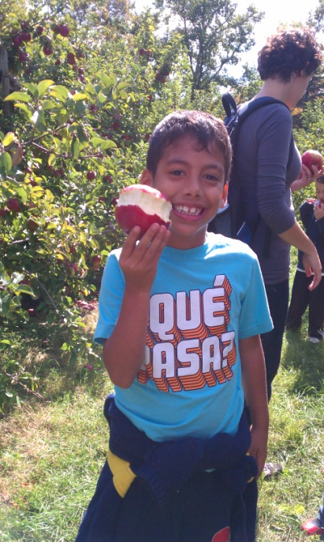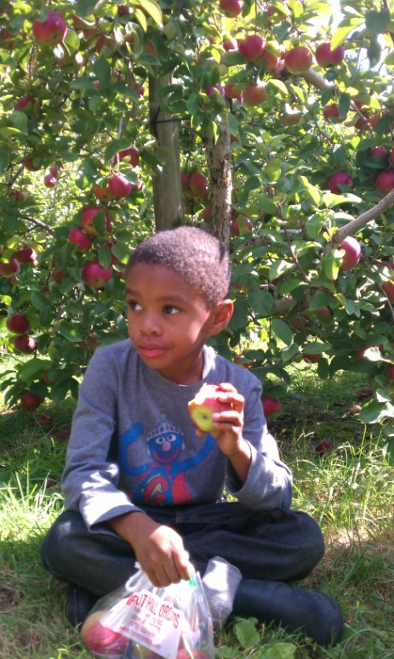

### First Grade Literacy

First grade has been practicing “Read to Self” (independent reading) and has worked up to 5 minutes of uninterrupted quiet reading time. Students have their own book box filled with books to read during this independent reading time. The book box has books on his/her reading level as well as books of student choice from our class library. We continue to discuss how to choose books from our class library and why people read.   
  
Please talk to your child about what you read and why you read. Do you like to read recipes or cookbooks? Do you enjoy a magazine that matches your interests? Do you follow a blog(s) online? It’s important for young readers to understand what and why readers read.