October 22, 2012

First Grade News

Mr. Franks and Ms. Keeper

### News

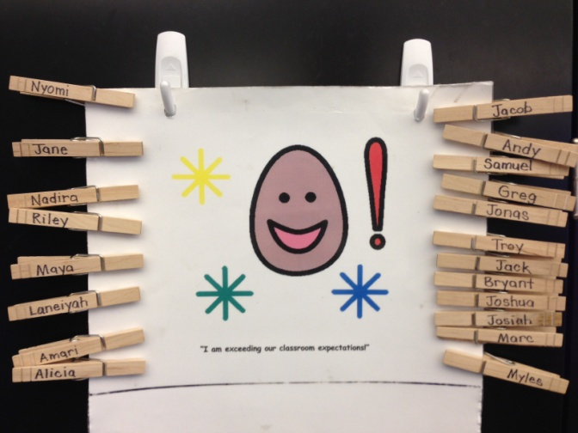

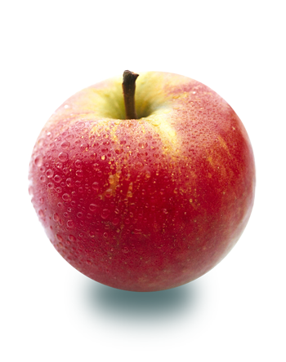

* Congratulations to Jonas Rincon our newest Student Spotlight!
* Happy birthday to Maya Ciani-Smith (Oct. 24th)!
* Attached to the newsletter is this week’s homework- the reading log. The goal is at least 2 hours of reading every week. Please return the completed book log next Monday. There are also 5 sight words attached to the newsletter. Please review these words with your child until s/he knows them automatically.
* Wednesday is an early dismissal day!
* Scholastic book order forms and money (cash or check) are due Wednesday. Order online at [www.clubs.scholastic.com/](http://www.clubs.scholastic.com/) Our class activation code is **GZJR4**
* Check out our updated class website and blog! See photos of what’s happening, print math games, and much more! keeperfranks.weebly.com

#### Save the Date!

# What’s Happening in First Grade?

Wow! What an amazing week! We filled our token jar and had our first class celebration. First grade voted for a dodge ball party, and we enjoyed a beautiful fall afternoon outdoors on Thursday. Have you heard about our American symbols unit? Last week we got together with Ms. Moulton’s class and looked at all kinds of familiar symbols. Then, we started talking about American symbols. Our first symbol was the Bald Eagle. Students watched a video clip of a Bald Eagle catching a fish with its talons. Then students listened to a read aloud about the Bald Eagle. Students wrote one thing they learned from the book. Next, as a class we wrote together what we had learned about this American symbol. Students then copied our words into their very own American symbols book. The next day students met in reading groups to read another book about Bald Eagles. It was a very challenging book and everyone persevered! Way to go first grade!   
Turn the newsletter over for additional math and literacy news and ways to help your child at home!

##### Election Day

##### Parent Council Meeting

Wednesday, Oct. 31

##### Fall Festival

Take your first grader to the polls with you and VOTE!

Turn the newsletter over for details!

6 pm Light Dinner

6:30-7:30pm Meeting

Wednesday, Oct. 24

Tuesday, Nov. 6

### First Grade Math

Last week we continued to work on combining numbers (adding) as well as addition story problems. Ways to support first grade math at home…

* Ask your child “Ways to Make” a number like 6 ( use numbers less than 10). Encourage your child to use manipulatives (ie. buttons, pennies) or a simple drawings as needed. See if your child uses a pattern or “turn-arounds” such as 6+0, 0+6, 5+1, 1+5, 4+2, 2+4, and 3+3.

* Tell your child simple addition or subtraction story problems. Ask him or her to solve them (with a total less than 20). Encourage your child to use manipulatives (ie. buttons, pennies) or a simple drawing as needed. Here are some examples:  
  + Andy has 3 cars. Greg has 3 cars. How many cars do they have in all?
  + Jane had 7 library books. She returned 2 of them. How many does she have left?
  + Mr. Downs had 4 jump ropes. He got 3 new jump ropes. How many does he have now?

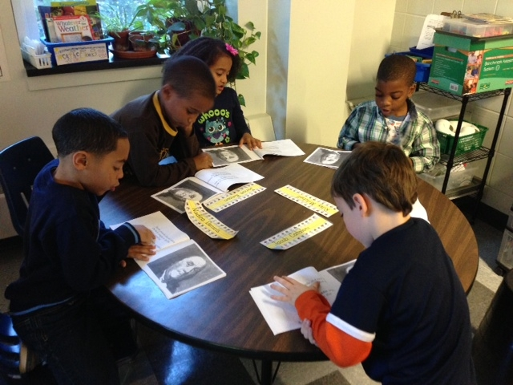

Social Studies & Literacy

Look at the readers in the photo above reading about Bald Eagles! Ask your child what s/he has learned about the American symbols we have studied so far-the Bald Eagle and the Statue of Liberty!

### Fall Festival and Halloween Celebration

Next Wednesday afternoon, October 31st, we will having a small fall celebration. Students can change into costumes at the end of the day (**DO NOT** wear costumes to school in the morning) but this is optional. Please do not send any face make-up or complicated costumes. Also, NHCS is not allowing masks. If you would like to send in a healthy snack for us to munch on during the Fall Festival, please do! Students can bring candy to pass out for classmates to take home.