October 29, 2012

First Grade News

Mr. Franks and Ms. Keeper

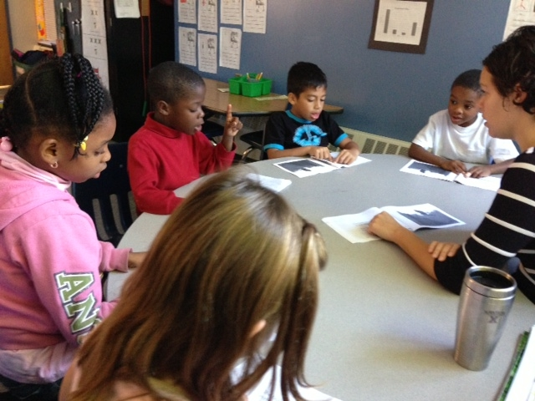

### News

* Congratulations to Riley Mitchell our newest Student Spotlight!
* Happy birthday to Nadira Daniels (Oct. 31st )!
* Attached to the newsletter is this week’s homework- the reading log. The goal is at least 2 hours of reading every week. Please return the completed book log next Monday. There are also 5 sight words attached to the newsletter. Please review these words with your child until s/he knows them automatically.
* Wednesday afternoon, October 31st, we will be having a small fall celebration. Students can change into costumes at the end of the day (**DO NOT** wear costumes to school in the morning) but this is optional. Please do not send any face make-up or complicated costumes. Also, NHCS is not allowing masks. If you would like to send in a healthy snack for us to munch on during the Fall Festival, please do! Students can bring candy to pass out for classmates to take home.
* Check out our updated class website and blog! See photos of what’s happening, print math games, and much more! keeperfranks.weebly.com

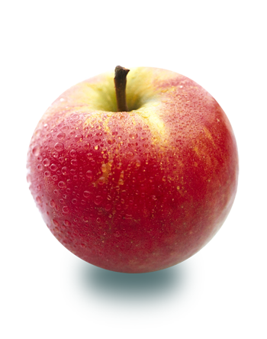

#### Save the Date!

##### Fall Festival

# What’s Happening in First Grade?

##### Veteran’s Day

See class News for details.

Monday, Nov. 12

Wednesday, Oct. 31

##### Election Day

Tuesday, Nov. 6

Take your first grader to the polls with you and VOTE!

No School!

This week we continued our study of American symbols. We learned about the American flag, the White House and the President. We even took a short tour online of the White House and found Boston and Washington DC on Google Maps. The students listened to a read aloud of each symbol, wrote about what they learned, and then read another book about each symbol in a small group. Students compared the information from the read aloud to the books they read in small groups using a chart. Then, as a class we discussed how to write about what we learned. We used a list to help us write to a short paragraph including an opening sentence, 2 important facts, and a closing sentence. Ask your child what facts s/he has learned about our American symbols. This week we will focus on the voting process and the presidential election.

No School!