First Grade News

September 10, 2012

#### Save the Date!

Mr. Franks and Ms. Keeper

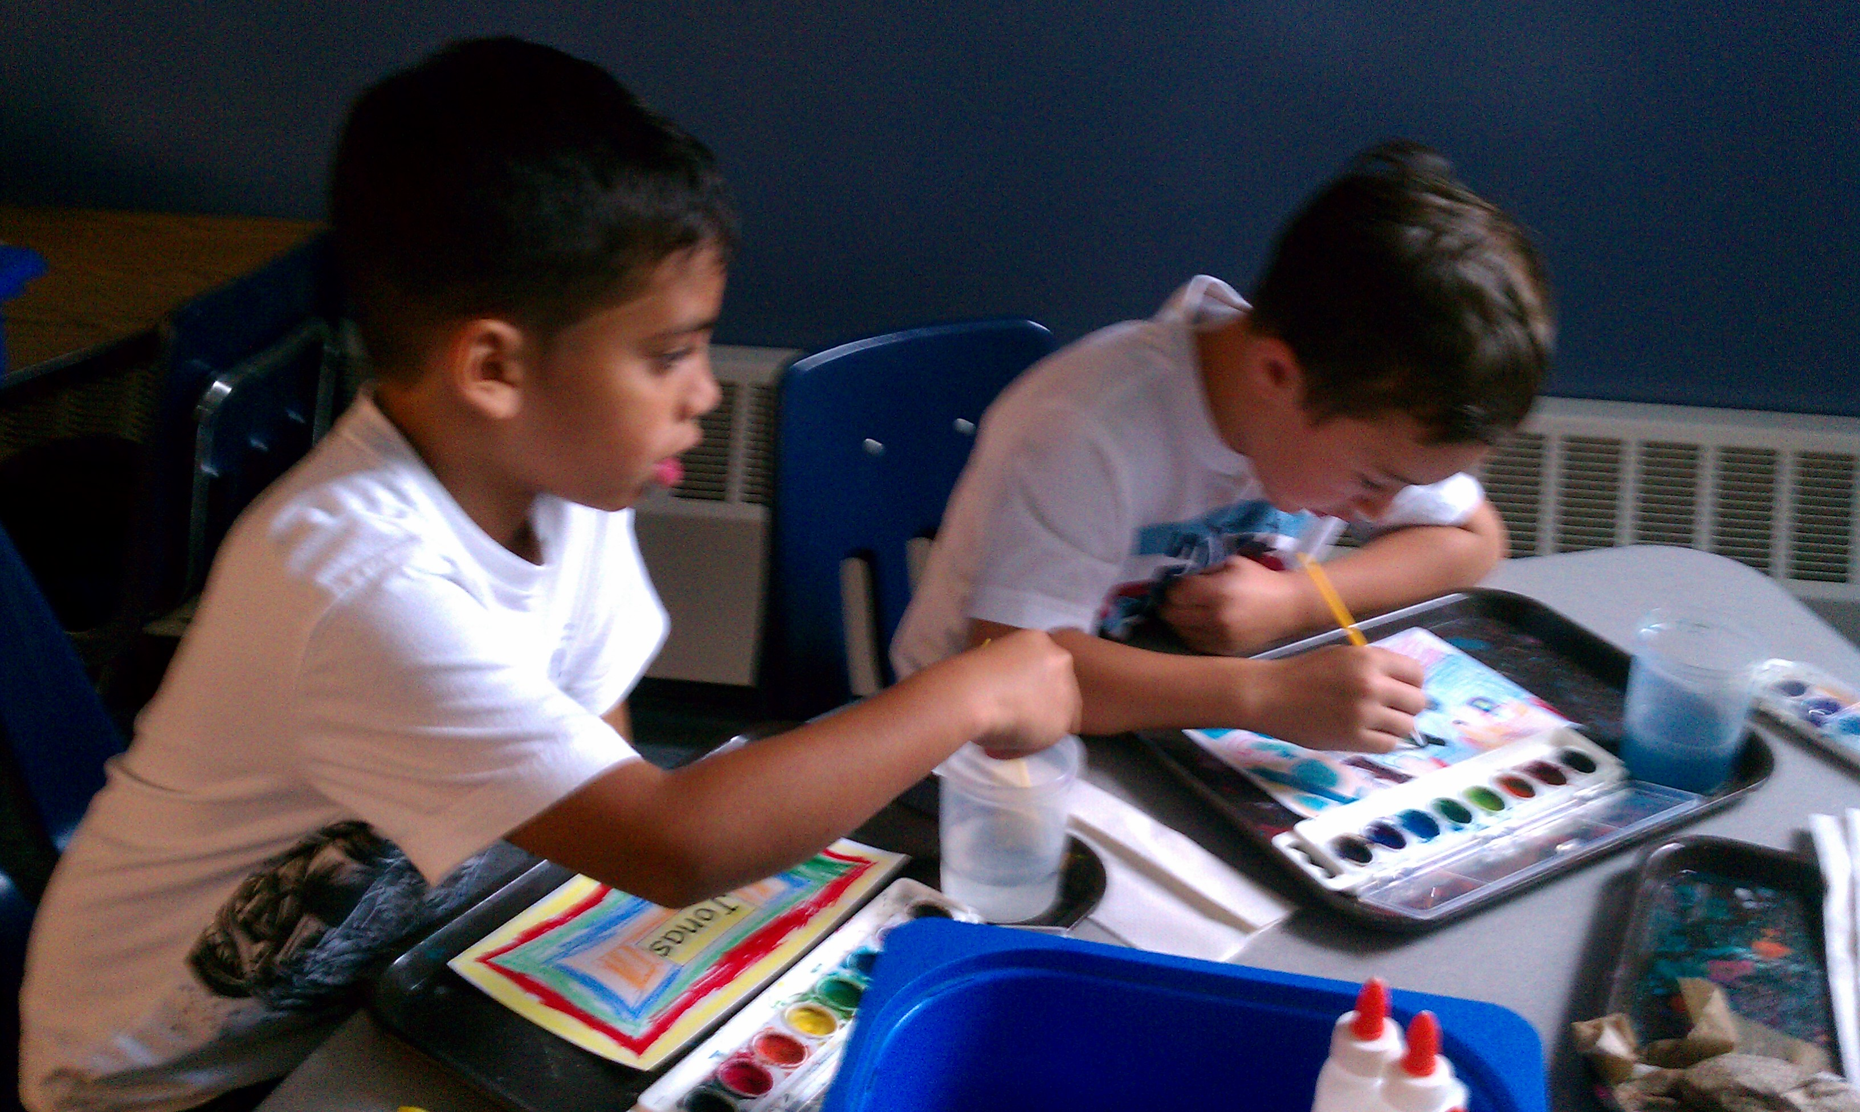

### News

* Happy belated birthday to Laneiyah Dennis (Aug. 23rd)
* It has been wonderful meeting all of our first grade families. We are so excited to work with you this year.
* If you have not sent in school supplies from the “Supply List” please do so as soon as possible.
* Wednesday is an early dismissal day.
* Don’t forget to save and send in your “Boxtops for Education.” Money raised supports our incredible music program.
* Scholastic Book orders are coming home today! Forms and money (cash or check) are due Friday, Sept 21.Order online at [www.clubs.scholastic.com/](http://www.clubs.scholastic.com/) Our class activation code is **GZJR4**
* Permission slips for our first field trip to the apple orchard are coming home today!
* Our first storytelling homework packet is coming home today. Please return it on Friday.

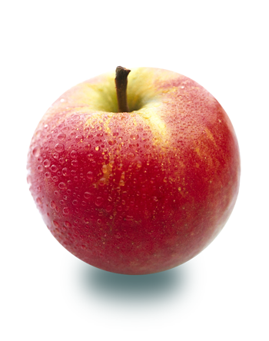

We had a fabulous first week together in first grade! We were busy, busy, busy practicing our new routines including using our lockers, stopping and listening for the bell in the classroom, and lining up before and after recess. We started our Identity Unit our first integrated social studies unit. We have been focusing on the question “What makes me, ME?” We also wrote and discussed what we know about books and what we know about people who love to read. First grade knows a lot about reading!

# What’s Happening in First Grade?

##### Early Dismissal Day

12:15 dismissal day

Wednesday, Sept. 26

##### Lower School Open House

Thursday, Oct. 4

Come see our class’ work on our Identity project.

Join us at Honey Pot Hill Apple Orchard 9am-2pm

##### Apple Orchard Field Trip

Thursday, Sept. 27