First Grade News

September 17, 2012

#### Save the Date!

Mr. Franks and Ms. Keeper

### News

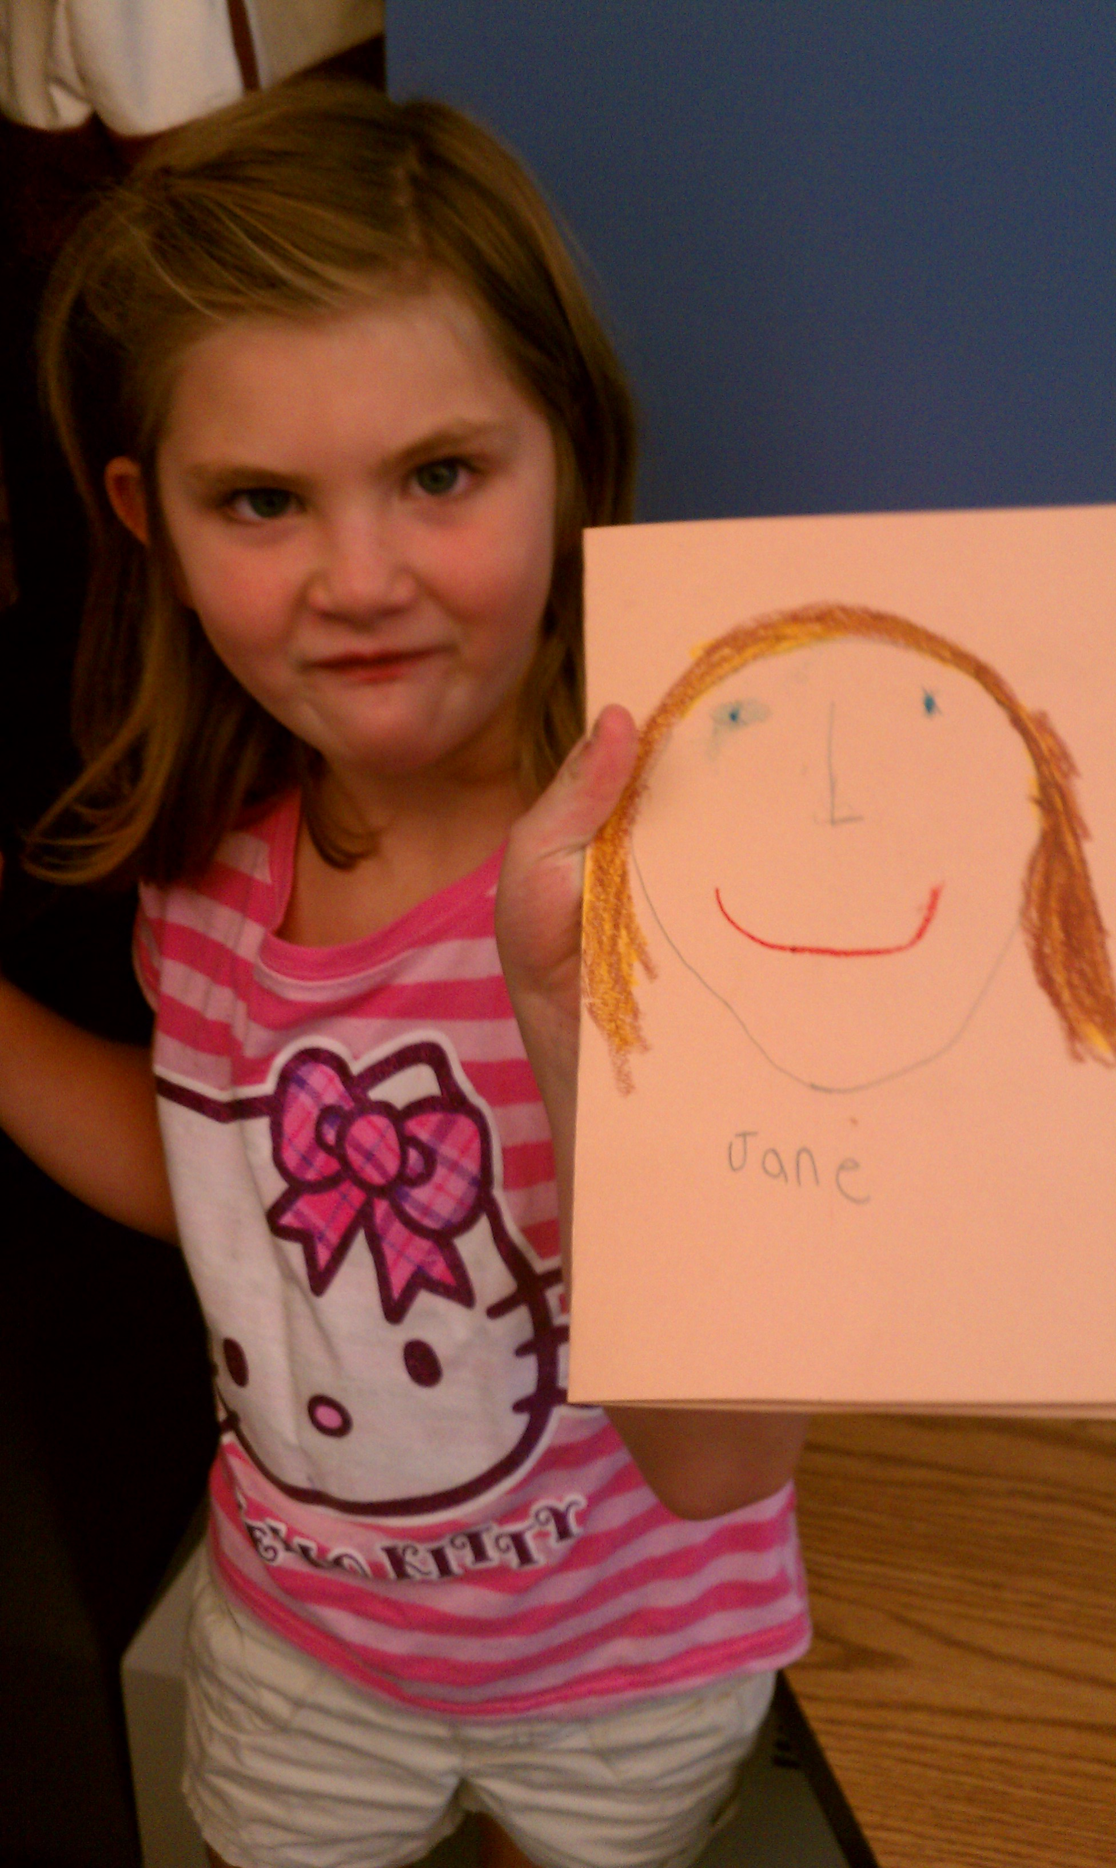

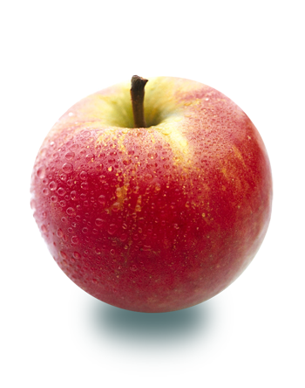

* Happy birthday to Bryant Sigler (Sept. 21st)!
* Congratulations to Andy Nova our first Student Spotlight
* Our first reading log is coming home today. The goal is two hours of reading a week. We will collect reading logs next Monday.
* Parent Council meeting this Wednesday, Sept. 19th 6-7:30pm
* If you have not sent in school supplies from the “Supply List” please do so as soon as possible.
* Permission slips and $10 for our first field trip to the apple orchard are due this Friday.
* Scholastic Book orders and money (cash or check) are due by Friday, Sept 21. Order online at [www.clubs.scholastic.com/](http://www.clubs.scholastic.com/) Our class activation code is **GZJR4**
* Don’t forget to save and send in your “Boxtops for Education.” Money raised supports our incredible music program.

# What’s Happening in First Grade?

Last week first grade read books about different characters including David, Wemberly, Ferdinand and Grace. Students independently wrote about “what makes that character who s/he is?” Then we discussed the question as a class. On Thursday, students choose one character to compare themselves too. Ask your child which book character s/he is most like and why. In math, we played many games to practice counting and comparing numbers. We talked about ways to make sure that you are counting accurately and how to compare two numbers (ie. which one is larger 6 or 8) using cubes to help us.

12:15 dismissal day

##### Early Dismissal Day

Wednesday, Sept. 26

##### Lower School Open House

Thursday, Oct. 4

Come see the Lower School’s work on the Identity project.

Join us at Honey Pot Hill Apple Orchard

##### Apple Orchard Field Trip

Thursday, Sept. 27