First Grade News

September 24, 2012

#### Save the Date!

Mr. Franks and Ms. Keeper

### News

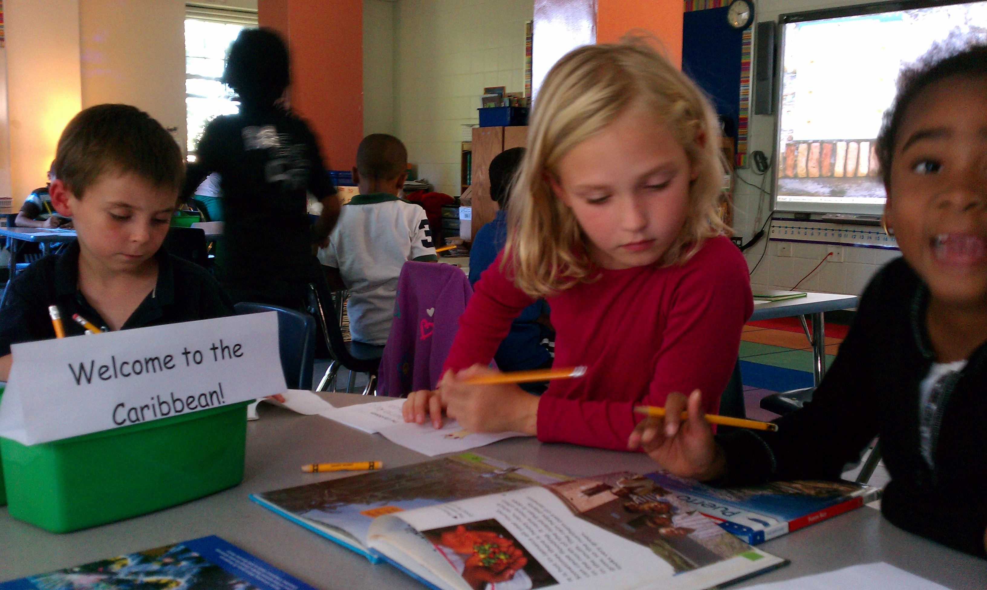

* Congratulations to Maya Ciani-Smith our newest Student Spotlight
* Storytelling homework packets and reading logs are coming home today. The goal is two hours of reading a week.
* If you have not sent in school supplies from the “Supply List” please do so as soon as possible.
* Wednesday is a 12:15pm dismissal day.
* Thursday is our field trip to Honey Pot Hill Apple Orchard! Please make sure your child is dressed appropriately for a day of outdoor fun. Please put your child’s lunch in a brown paper bag or plastic grocery bag with their NAME and teacher’s name clearly visible. School lunches will be provided for those who receive school lunch. If you are chaperoning please arrive at school by 8:45 am. We are departing at 9am.
* Please make sure your child brings a small snack to school daily.

Wish List

* School snack (nothing with nuts please)

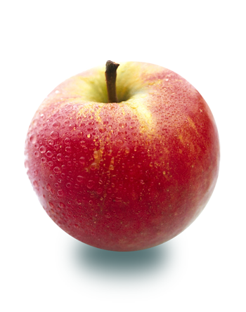

As part of our identity unit, last week first grade launched Writing Workshop. Students have been busy writing stories about their families. We also took a journey around the world on Wednesday and Thursday complete with passports and “an airplane.” Students rotated to different stations to explore books about the different regions of the world where their classmates’ families are from. Students recorded notes and pictures in their passports. In math, we continued to work on combining numbers. We also began solving addition story problems.

# What’s Happening in First Grade?

More information coming soon

Come see the Lower School’s work on the Identity project.

Thursday, Oct. 4 6-7pm

##### Class Picture Day

Thursday, Oct. 4

##### No School-Columbus Day

Monday, Oct. 8

##### Lower School Open House